Problem Statment

Water pollution is defined as water bodies for example lakes, oceans, and rivers that are affected by pollutants which are discharged in water masses whether this happens directly or indirectly. Pollutants include oil leaks, sewage and wastewater, and industrial waste.
One of the main causes of water pollution is oil leaks. Oil pollution occurs when oil spills accidentally from tanks that are on ships that travel from port to port. Ships pollute ocean water by leaking oil into it resulting in major damage to the water and creatures living in it. Accidental oil leaks have caused a lot of beaches to be evacuated and many animals to die and be endangered. Petroleum is a toxic component and causes a huge problem to the ecosystem. Oil does not dissolve in water and forms a thick substance.
The second cause of water pollution is sewage and wastewater. With many people on our planet sewage waste is a problem. Sewage comes from households, and factories when you flush the toilet, there is still waste to dispose of. Sewage can be a problem when people flush chemicals down the toilet. Sewage water is transferred into the rivers with no proper treatment or if it is treated it is done in a very poor manner. On some occasions, sewage waste is pumped into the sea without it being treated properly.
Finally, industrial waste also causes water pollution. Industrial waste from factories which contains toxic chemicals and pollutants. Many factories and industries do not have a proper way to dispose of their waste so they just drain them into our seas and oceans. These toxic chemicals can change the color of the water and can cause the water to be harmful to us as humans and for the sea creatures.
This is a good start to your problem statement, but the last two component are missing! Review the "Writing the Needs or Problem Statement" PDF that I provided to the class on Canvas... and pay special attention to pages 45-46. Adding those last two sections will make this even stronger.

Goals and Objectives
Goal #1: Maintenance – Oil pollution occurs when oil spills accidentally from tanks that are on ships that travel from port to port. Tighten bolts on engines to prevent oil leaks. Bolts can shake loose with engine use. Oil safety valve should be installed on the supply line of your heating system if you do not already have one. The safety valve will automatically shut off the oil supply if the line breaks.

Goal #2: Proper sewage treatment – Sewage and wastewater come from households, and factories when you flush the toilet, there is still waste to dispose of. Eco-friendly wastewater treatment options, such as recycling sewage sludge to carbon-phosphorous fertilizer, are other solutions. By doing this we will achieve the goal of preventing water pollution.

Goal #3: Cut down on industry waste – Industrial waste from factories which contain toxic chemicals and pollutants. Industry and manufacturing must cut down on waste and contain landfills so they don't spill into the ocean. This goal will help prevent the problem.
The best goals have MEASURES... numbers to guide them and make them more SPECIFIC! How much can be spent? What is the TIME FRAME?

You will want to revise these further!

…………………………………… …………………………………… …………………………………… ……………………………………
Roster of Participants
The group was carefully chosen after a series of interviews and a lot of consideration. Every member of this group is very dictated to our cause which is to help reduce water pollution. With that in mind, our team works extremely hard to achieve our ultimate goal. We have three main problems oil spills, sewage and wastewater, and industrial waste.
Each of these problems has their team, that works together with organizations and industries by having liaisons. For example, we have liaisons working inside factories to help us help them go through the proper process of getting rid of their waste instead of dumping them. By having liaisons we can communicate with cooperation, and create a close working relationship. Every team has a creative analyst that help provide us with new and creative ways to solve the problem. Also, we have a data analyst that analyze the given information to help our team. Also, every department has a chief that encourages the team and makes sure everything is running smoothly. Finally, the head chairwoman is the go-to for any problems that might occur and needs to be resolved.
Every department team will work together to solve the problems regarding water pollution. All department chiefs will gather and have a meeting with the chairwoman and discuss all the issues that need to be discussed regularly. E-mail is an essential way to communications with each in our organization.
I think your roster would be improved by adding some government representatives... add some fictitious people from the federal government (EPA, NOAA, etc.) as well as some state or local reps near areas that would be affected by the project!

Collaborative Session Participants
NAME | ORGANIZATION | TITLE | PHONE | EMAIL ADDRESS
Jo willson | BP Organization | Oil department chief | (402)-111-1111 | JW@gmail.com
Mike smith | BP Organization | Oil liaison | (402)-222-2222 | MS1@gmail.com
Kensi Blye | Dell EMC | Creative analysts | (402)-333-3333 | KB@gmail.com
Jack Simon | Dell EMC | Data analysts | (402)-444-4444 | JS@gmail.com
Nell Jones | Surfers Against Sewage | Sewage and wastewater chief | (402)-555-5555 | NJ@gmail.com
Eric Beal | Surfers Against Sewage | Sewage and wastewater liaison | (402)-666-6666 | EB@gmail.com
Owen Granger | Dell EMC | Creative analysts | (402)-777-7777 | OG@gmail.com
Antony Dinozzo | Dell EMC | Data analysts | (402)-888-8888 | Ad@gmail.com
Ziva David | National Waste and Recycling | Industrial waste chief | (402)-999-9999 | ZD@gmail.com
Patrick Jane | National Waste and Recycling | Industrial waste liaison | (402)-000-0000 | PJ@gmail.com
Alex Kerev | Dell EMC | Data analysts | (402)-101-1010 | AK@gmail.com
Mark Sloan | Dell EMC | Creative analysts | (402)-000-0001 | MS@gmail.com
Callie Torres |  | Head chairwoman | (402)-000-0002 | CT@gmail.com

Agenda
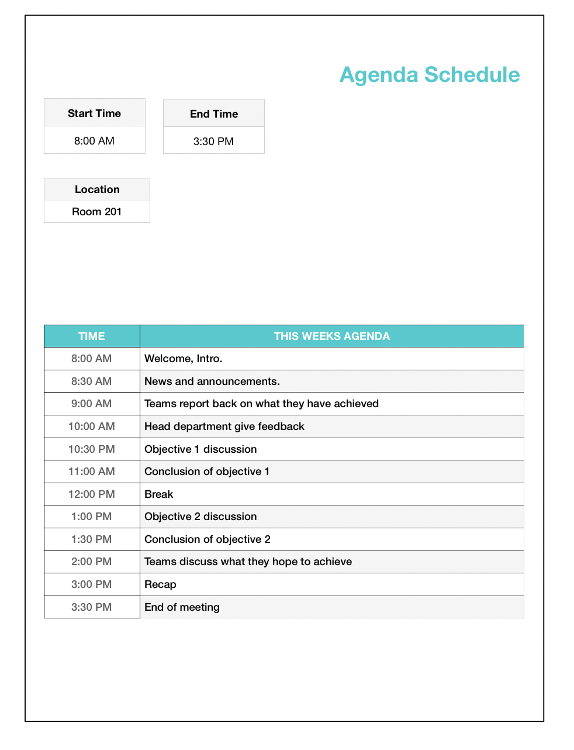
Our organization holds the meetings at the same time and place each week. We send the agenda out beforehand. We identify what we hope to accomplish from these meetings. As an organization we try our best to recognize progress made by team efforts and not only individuals, because when we only recognize one individual for a team effort this will cause resentment among the team members that have not been recognized. The agenda is placed where everyone has access, review and contribute.
A good start, but the agenda items would benefit from more specificity. The way it looks right now, it appears to be more of a presentation/discussion meeting than a collaborative session!

You should be more specific in your activity titles shown... place more emphasis on each COLLABORATIVE SUB-TASK inside those blocks (When will the group BRAINSTORM? When will they EVALUATE alternatives? When will the vote/decide on a solution?) Predict how long it would take the group to complete each sub-task.

Come see me if you have questions about this, okay?

…………………………………… …………………………………… …………………………………… ……………………………………

Activity #1: ActivityName
TOOL/METHOD: Brainstorming
PARTICIPANTS: All teams
MATERIALS: To complete the tasks we need all the information gathered by the team beforehand.
TIME ALLOTTED: 60 minutes (1:00 PM – 2:00 PM )
INSTRUCTIONS:

First, we need to know what our objective is, in our case our objective is to stop water pollution. The teams will get together and discuss this issue and every aspect of this issue. After that, the teams will identify the problems that contribute to water pollution oil leaks, industrial waste ect… Each team will work and brainstorm ideas and solution to stop water pollution. Brainstorming is a great way to figure out how to improve a system or solve a problem. The teams will conduct brainstorming sessions, they will meet and get together and come up with ideas on how to deal with our issue. It’s all about getting creative thoughts flowing without shooting down anyone’s ideas.
After the brainstorming session is over, the teams will be divided into groups every group will deal with a specific solution to our problem which is water pollution. The group leaders will get together and clarify theirs groups task so everyone knows what they are doing. All of the groups and leaders will come together and discuss their findings. Then the groups will prioritize the solutions and see what should be done first.

Finally, we will deliver the solution and work on them.
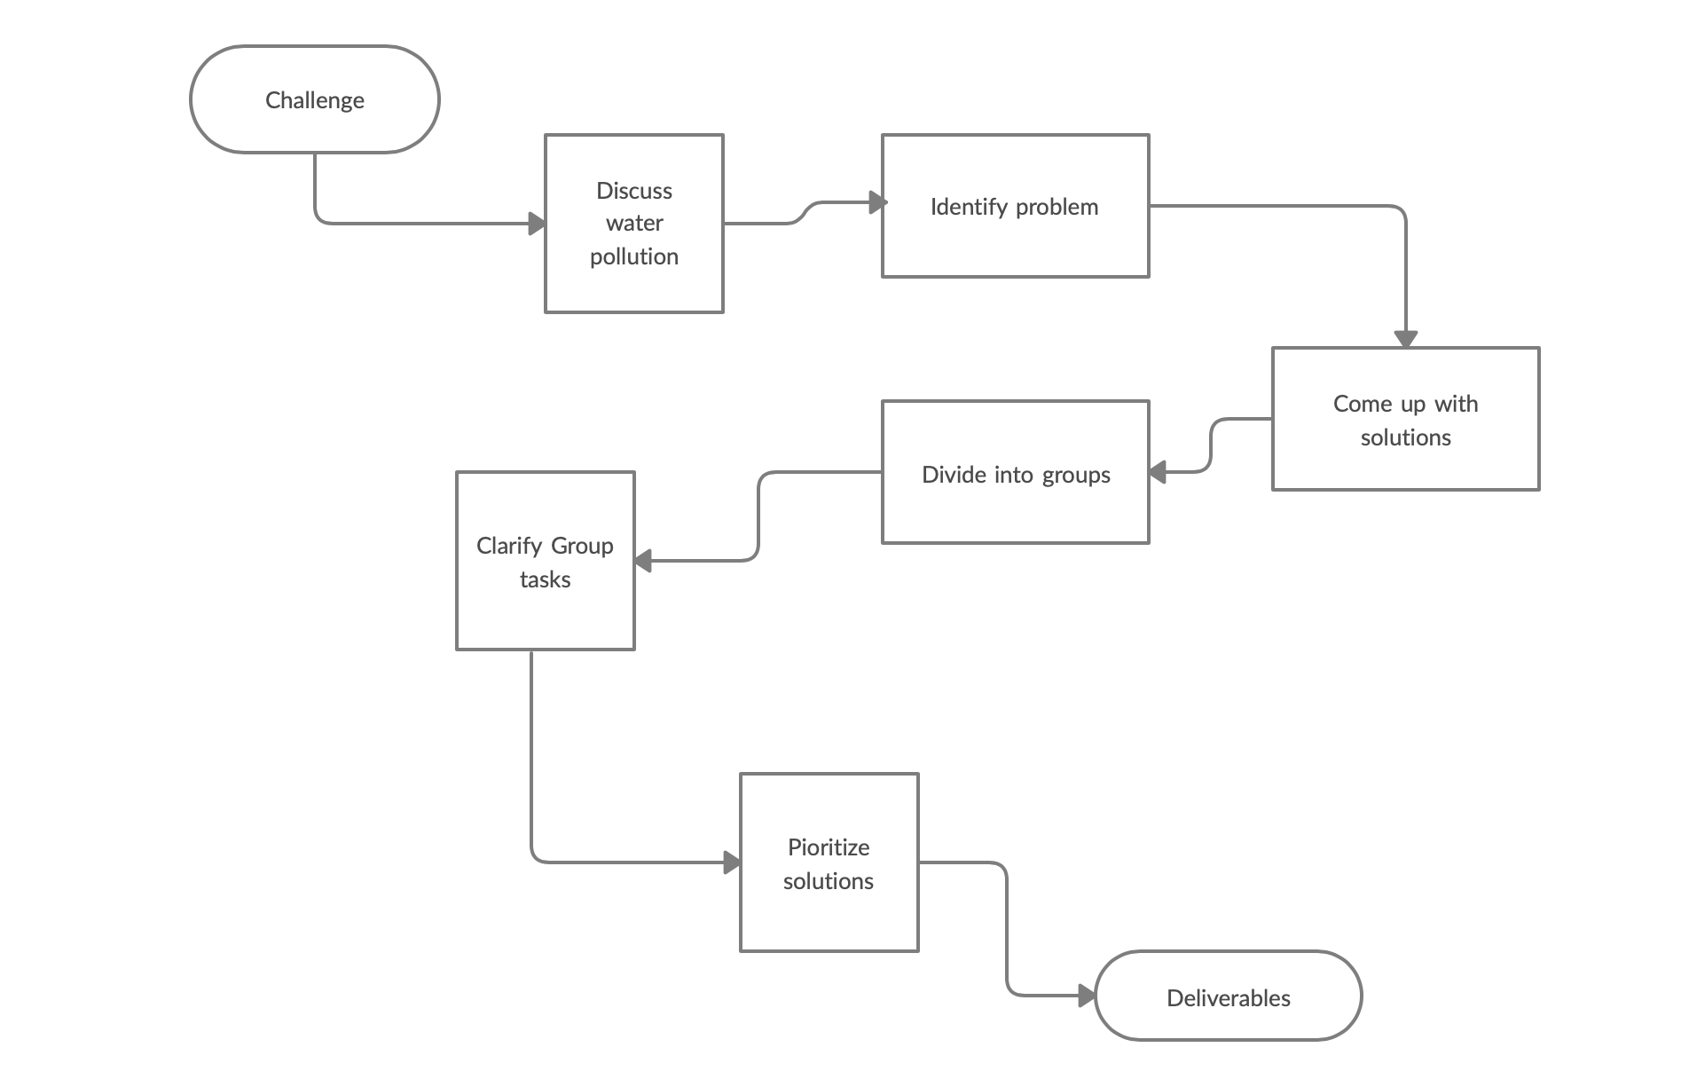

This is a good start, but it needs to be MUCH more specific in the details.

One big thing missing is the actual question to be answered -- this has to be asked perfectly!

There's subtle differences between slightly reworded questions... And you don't want your participants to have to guess!

Be specific... every task has a question and you've got to identify the best one.

Also, how will they submit their responses? What actions do they need to do? You MUST be very specific in your instructions... if you don't, theres no telling what kind of responses you will get.

…………………………………… …………………………………… …………………………………… ……………………………………

Process Diagram

This is a good start... just remember to:

1) label the inputs and outputs of each activity;
2) insert a voting activity where the group can identify the solution(s) that they want to proceed with (VOTING is different than PRIORITIZATION); and
2) show an "iterative loop" for your voting/selection activities, as you're unlikely to get a concrete answer after just one vote.

Activity #2
TOOL/METHOD: Brainstorming/Mind Mapping
PARTICIPANTS: All teams
MATERIALS: To complete the tasks we need all the information gathered by the team beforehand.
TIME ALLOTTED: 60 minutes (1:00 PM – 2:00 PM )
INSTRUCTIONS:
The room setting and atmosphere is very important to us as an organization. The room will have just enough space so team members aren’t crowded but the room will not too large that the empty space sucks all the energy out of the room. The room will be arranged so that the chairs in a u-shape. Communication is the key to a successful meeting and we want all the members to be able to see and hear each other. A whiteboard will be placed at the opening so all members can see and focus on the task at hand. Since our meeting will last for an hour, the chairs will have wheels on them, armrests are good and extra padding for comfort. There will be water bottles on the tables in front of each chair. Given the time of our meeting which is close to lunchtime, we will provide drinks as well as snacks such as; bagels, muffins, cookies, cheese, and crackers. Pens and notepads will also be provided and placed on the table. An essential oil diffuser will be in the room with scents such as jasmine, and lavender to stimulate creativity, concentration, and relieve stress.
A brainstorm meeting is a long and free form meeting design. Excellent for discussing topics, ideas, and solutions. We encourage all our team members to respect everyone's ideas and to not downgrade someone ideas. The main aim is to get creative thoughts flowing without shooting down anyone’s ideas. The teams will be using the whiteboard to draw a simple mind map; so everyone can see their ideas. A mind map is a graphical way to represent ideas and concepts from the brainstorming session. It is a great visual thinking tool that helps to structure information, generating new ideas, and identifying relationships among different data and information. Making a mind map is an excellent way for the teams to be able to sort through their thoughts and ideas. Mind maps allow team members to quickly generate creative and unique ideas in a short time period. It gives them the freedom they need when brainstorming so that the flow of ideas is not blocked. After the brainstorming and mind mapping session is over, all of the groups and leaders will discuss their ideas, and solutions and what they will do with what they have. Communication is a crucial key for everything to run smoothly. The groups will prioritize the solutions and see what should be done first. Finally, we will deliver the solution and work on solving this problematic issue.
Still requires MUCH more activity detail! What is the EXACT question they are considering in this activity? How do the participants contribute their ideas?

…………………………………… …………………………………… …………………………………… ……………………………………

Activity #3
TOOL/METHOD: Brainstorming/Mind Mapping
PARTICIPANTS: All teams
MATERIALS: To complete the tasks we need all the information gathered by the team beforehand.
TIME ALLOTTED: 60 minutes (1:00 PM – 2:00 PM )
INSTRUCTIONS:

The room setting and atmosphere is very important to us as an organization. The room will have just enough space so team members aren’t crowded but the room will not too large that the empty space sucks all the energy out of the room. The room will be arranged so that the chairs in a u-shape. Communication is the key to a successful meeting and we want all the members to be able to see and hear each other. A whiteboard will be placed at the opening so all members can see and focus on the task at hand. Since our meeting will last for an hour, the chairs will have wheels on them, armrests are good and extra padding for comfort. There will be water bottles on the tables in front of each chair. Given the time of our meeting which is close to lunchtime, we will provide drinks as well as snacks such as; bagels, muffins, cookies, cheese, and crackers. Pens and notepads will also be provided and placed on the table. An essential oil diffuser will be in the room with scents such as jasmine, and lavender to stimulate creativity, concentration, and relieve stress.

A brainstorm meeting is a long and free form meeting design. Excellent for discussing topics, ideas, and solutions. We encourage all our Team members to respect everyone's ideas and to not downgrade someone ideas. The main aim is to get creative thoughts flowing without shooting down anyone’s ideas. The teams will be using the whiteboard to draw a simple mind map; so everyone can see their ideas. A mind map is a graphical way to represent ideas and concepts from the brainstorming session. It is a great visual thinking tool that helps to structure information, generating new ideas, and identifying relationships among different data and information.

Making a mind map is an excellent way for the teams to be able to sort through their thoughts and ideas. Mind maps allow team members to quickly generate creative and unique ideas in a short time period. It gives them the freedom they need when brainstorming so that the flow of ideas is not blocked. After the brainstorming and mind mapping session is over, all of the groups and leaders will discuss their ideas, and solutions and what they will do with what they have. Communication is a crucial key for everything to run smoothly. The groups will prioritize the solutions and see what should be done first. Finally, we will deliver the solution and work on solving this problematic issue.

Our main issue/question is “How to clean our water recourse?” Team member will spend half an hour brainstorming answers to this question, then they will spend another half an hour drawing a mind map on a whiteboard using colored marker to make it easy to read and more interesting. Then each team will go to the front of the meeting room and present and show
their ideas/mind map to the whole team using the whiteboard. Anyone how has a question or wants to contribute can do so by waiting until the presenter is finished taking and then say what they wish to say. Ideally we would like everyone to concentrate with whoever is presenting. Contributing in a meetings does not only involve positive contributions, anyone that is able to highlight any problem or issue can and should use the meeting as a way of addressing them.

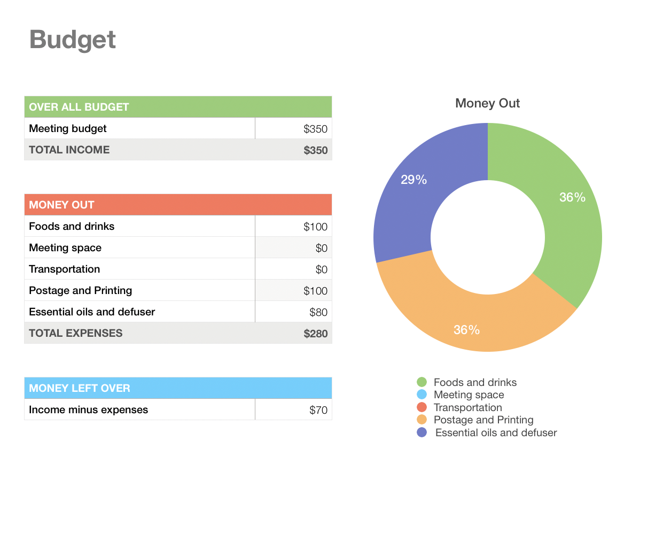
Our budget for this meeting is $350 and any remaining money from this meeting will go into next weeks meeting. The meeting room does not cost anything since it is in our company building. That being said there will be no transportation fee because everyone who will be attending this meeting will be from our company. Dinks and snacks will cost approximately $100, the essential oil diffuser and essential oil will cost $80. Postage and Printing such as, pens, notepads, and whiteboards will const $100. This brings the total payed for this meeting to $280, with $70 left.

